**Czech University of Life Sciences Prague**

**Faculty of Economics and Management**



**Consumption of Apples in Czech**

**Republic**

**SADMAN AMIR**

**Table of Contents**1. One-Equation Model ................................................................................................................. 3  
1.1. Economic and Econometric Models........................................................................................ 3  
1.2. Data Set .................................................................................................................................. 3  
1.3. Estimation of Parameters........................................................................................................ 6  
1.4. Economic verification of the Model ....................................................................................... 6  
1.5. Model Application................................................................................................................... 7  
2. Simultaneous Model ................................................................................................................. 9  
2.1. Economic and Econometric Model ........................................................................................ 9  
2.2. Data Set ................................................................................................................................. 10  
2.3. Model Identification.............................................................................................................. 11  
2.4. Estimation of Parameters using TSLSM................................................................................. 12  
2.5. Model Verification................................................................................................................. 13  
2.6. Matrix B, Γ, M & Reduced Form............................................................................................. 15  
2.7. Model Application................................................................................................................. 16  
3. Conclusion ................................................................................................................................ 19  
4. References................................................................................................................................. 19

**1. One Equation Model**

**Introduction**

The endogenous variable in the model is the consumption of Apple in Czech Republic from 2001 to 2018. It is assumed the consumption of Apple is related to the price of Apple and price of other fruits which can be used as substitutes such as strawberries and oranges. It is also assumed that the income of households also affects the consumption of Apples.

**1.1 Economic and Econometric Models**

Consumption of Apples is a function of consumer price of apple, consumer price of oranges and strawberries as well as income of households.

Economic model: y1 = f (x2t, x3t,x4t, x5t)

Econometric model: y1t = γ1x1t + γ2x2t + γ3x3t+ γ4x4t + γ5x5t + u1t

**1.2 Data Set**

**Variables**

y1t consumption of apples

x1t unit vector

x2t consumer price of apples

x3t consumer price of strawberries

x4t consumer price of oranges

x5t household income

|  |  |  |  |  |  |  |
| --- | --- | --- | --- | --- | --- | --- |
| Year | Consumption of Apples (kg/year) | Consumer price of Apples (czk/kg) | Consumer price of Strawberries (czk/kg) | Consumer price of Oranges (czk/kg) | Household Income (thousands czk) | UV |
| y1t | x2t | x3t | x4t | x5t | x1t |
| 1999 | 22.60 | 26.96 | 27.57 | 27.03 | 130.779 | 1 |
| 2000 | 21.96 | 26.56 | 27.21 | 26.78 | 130.53 | 1 |
| 2001 | 22.00 | 23.61 | 28.43 | 27.92 | 131.601 | 1 |
| 2002 | 24.7 | 17.78 | 27.78 | 27.51 | 137.635 | 1 |
| 2003 | 23.8 | 21.62 | 31.13 | 22.93 | 143.184 | 1 |
| 2004 | 24.2 | 20.57 | 28.49 | 33.84 | 151.129 | 1 |
| 2005 | 24.4 | 20.57 | 26.17 | 34.2 | 159.04 | 1 |
| 2006 | 26.6 | 23.27 | 25.94 | 28.61 | 170.177 | 1 |
| 2007 | 24.6 | 29.14 | 25.59 | 29.22 | 179.836 | 1 |
| 2008 | 26.47 | 24.83 | 25.67 | 26.9 | 191.021 | 1 |
| 2009 | 26.69 | 21.68 | 27.81 | 26.73 | 195.814 | 1 |
| 2010 | 22.46 | 27.76 | 27.77 | 26.27 | 196.56 | 1 |
| 2011 | 19.98 | 26.29 | 27.51 | 26.12 | 197.017 | 1 |
| 2012 | 19.11 | 30.94 | 25.05 | 31.82 | 198.881 | 1 |
| 2013 | 20.19 | 31.62 | 27.73 | 32.74 | 198.632 | 1 |
| 2014 | 21.21 | 26.09 | 26.5 | 31.1 | 202.915 | 1 |
| 2015 | 22.32 | 30.3 | 29.39 | 27.16 | 206.998 | 1 |
| 2016 | 24.3 | 28.36 | 27.61 | 30.67 | 208.32 | 1 |
| 2017 | 25.14 | 27.6 | 27.29 | 29.84 | 209.45 | 1 |
| 2018 | 25.4 | 29.5 | 29.46 | 30.19 | 210.56 | 1 |
| 2019 | 25.00 | 28.80 | 29.90 | 29.90 | 213.27 | 1 |

Source: <https://www.czso.cz>

**Correlation Matrix**

y1t x2t x3t x4t x5t

y1t 1

x2t -0.4319 1

x3t 0.0798 -0.0694 1

x4t -0.0930 0.1432 -0.3410 1

x5t 0.0129 0.6137 -0.0547 0.2368 1

**Multicollinearity:**

The problem of high multicollinearity does not exist because the values of the correlation coefficients between the explanatory variables are lower than 0.8.

**Matrix X Vector Y**

|  |  |  |  |  |  |  |  |
| --- | --- | --- | --- | --- | --- | --- | --- |
| x1t | x2t | x3t | x4t | x5t |  |  | y1t |
| 1 | 26.96 | 27.57 | 27.03 | 130.78 |  |  | 22.60 |
| 1 | 26.56 | 27.21 | 26.78 | 130.53 |  |  | 21.96 |
| 1 | 23.61 | 28.43 | 27.92 | 131.60 |  |  | 22.00 |
| 1 | 17.78 | 27.78 | 27.51 | 137.64 |  |  | 24.70 |
| 1 | 21.62 | 31.13 | 22.93 | 143.18 |  |  | 23.80 |
| 1 | 20.57 | 28.49 | 33.84 | 151.13 |  |  | 24.20 |
| 1 | 20.57 | 26.17 | 34.20 | 159.04 |  |  | 24.40 |
| 1 | 23.27 | 25.94 | 28.61 | 170.18 |  |  | 26.60 |
| 1 | 29.14 | 25.59 | 29.22 | 179.84 |  |  | 24.60 |
| 1 | 24.83 | 25.67 | 26.90 | 191.02 |  |  | 26.47 |
| 1 | 21.68 | 27.81 | 26.73 | 195.81 |  |  | 26.69 |
| 1 | 27.76 | 27.77 | 26.27 | 196.56 |  |  | 22.46 |
| 1 | 26.29 | 27.51 | 26.12 | 197.02 |  |  | 19.98 |
| 1 | 30.94 | 25.05 | 31.82 | 198.88 |  |  | 19.11 |
| 1 | 31.62 | 27.73 | 32.74 | 198.63 |  |  | 20.19 |
| 1 | 26.09 | 26.50 | 31.10 | 202.92 |  |  | 21.21 |
| 1 | 30.30 | 29.39 | 27.16 | 207.00 |  |  | 22.32 |
| 1 | 28.36 | 27.61 | 30.67 | 208.32 |  |  | 24.30 |
| 1 | 27.60 | 27.29 | 29.84 | 209.45 |  |  | 25.14 |
| 1 | 29.50 | 29.46 | 30.19 | 210.56 |  |  | 25.40 |
| 1 | 28.80 | 29.90 | 29.90 | 213.27 |  |  | 25.00 |

**1.3 Estimation of Parameters**

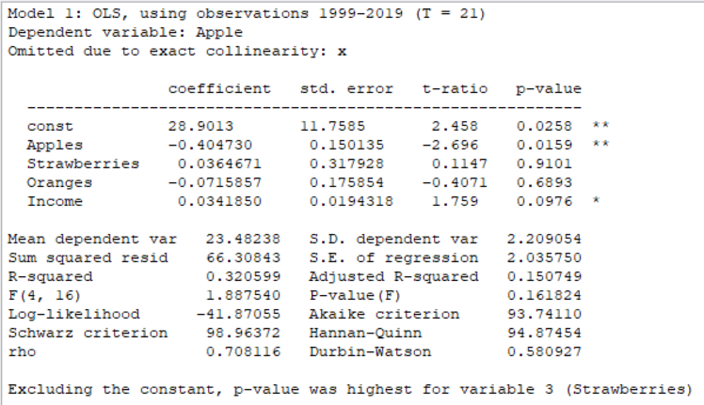

**Econometric Model**

y1t = 28.9013 – 0.404730 x2t + 0.0364671 x3t – 0.0715857 x4t + 0.0341850 x5t + ut

**1.4 Economic verification of the Model**

|  |  |
| --- | --- |
| 29.9013 | γ 1 |
| - 0.404730 | **γ 2** |
| 0.0364671 | **γ 3** |
| - 0.0715857 | **γ 4** |
| 0.0341850 | **γ 5** |

If all other variables are 0, consumption of Apples is **29.9013**(γ1) kg/year per individual.

If the price of Apple increases by 1%, the consumption of apple will be reduced by 0.404730(γ2) kg/year per individual.

If the price of strawberries increases by 1%, the consumption of apples will increase by 0.036467(γ3) kg/year per individual.

If the price of oranges increases by 1%, the consumption of apples will decrease by 0.0715857(γ4) kg/year per individual. This violates the basic assumption of considering orange as a substitute for Apple. However, we may see Apple and orange as complimentary products according this sample.

If the income of households increases by 1%, then the consumption of apples will increase by 0.0341850(γ5) kg/year per individual.

* + 1. **Significance of Parameter Coefficients**

In the model parameter coefficients for UV (γ 1) and Consumer Price of Apple (γ 2) are statistically significant in 98% confidence interval. The other parameter coefficients are not significant. That means only Consumer Price of Apple explains the consumption of Apple in 98% level of confidence.

**Coefficient of Determination R2**

**R2= 32%** The model explains 32% of the variation in consumption of Apple.

**Durbin-Watson Test**

**DW** = 0.580927

Since 0 < DW (0.580927) < 2, there seems to be a positive autocorrelation in the model.

**1.5 Model Application**

**Elasticity**

ŷ =28.9013 – 0.404730 x2t + 0.0364671 x3t – 0.0715857 x4t + 0.0341850 x5t

Theoretical ŷ for 2018 =28.9013 – (0.404730*29.50) + (0.0364671*29.46) – (0.0715857*30.19) + 0.0341850*210.56

**2018\***

|  |  |  |  |
| --- | --- | --- | --- |
| 29.50 | 29.46 | 30.19 | 210.56 |
|  |  |  |  |

Ŷ**2018** = 23.07290708

**Elasticity for 2018:**

x2 x3 x4 x5

-0.5174 0.0465 -0.0936 0.312

The most effect on consumption for consumer price of Apple and strawberry reach the highest level among other fruits as elasticity coefficients of them.

**Price of Apple**

If the price of Apple goes up by 1% then the consumption of Apple will go down by 0.5174%

**Price of Strawberry**

If the price of strawberry goes up by 1% then the consumption of Apple will go up by 0.0465%.

**Price of Orange**

If the price of orange goes up by 1% then the consumption of Apple will down up by 0.0936%.

**Household Income**

If the household income increases by 1% then the consumption of Apple will go up by 0.312%.

**Scenario Simulation**

What will be the consumption of apple if income increases by 10% in 2018?

E= 0.312 %

Δy= 23.07290708+[23.07290708*(0.00312*10] = 23.79278178

If the income increases by 10% then the new consumption of Apple will be 23.79278178 kg.

**2. Simultaneous Model**

**2.1. Economic and Econometric Model**

**Variables**

Endogenous variables

y1t consumption of Apples

y2t consumption of strawberries

y3t consumption of oranges

Exogenous variables

x1t unit vector

x2t price of Apples

x3t price of strawberries

x4t price of oranges

x5t household income

**Economic Model**

y1t = f (y2t, x1t, x2t, x5t)  
y2t = f (y3t, x1t, x3t)   
y3t= f (y1t, x1t, x4t)

**Econometric Model**

y1t = β12y2t + γ11x1t + γ12x2t + γ13x5t + u1t  
y2t = β21y3t + γ21x1t + γ22x3t + u2t  
y3t = β31y1t + γ31x1t + γ33x4t + u3t

**2.2 Data Set**

|  |  |  |  |  |  |  |  |  |
| --- | --- | --- | --- | --- | --- | --- | --- | --- |
| Year | Consumption kg/person/year | | | Consumer price czk/kg | | | Income | UV |
| Apple | Strawberry | Orange | Apple | Strawberry | Orange |
| *y1* | *y2* | *y3* | *x2* | *x3* | *x4* | *x5* | *x1* |
| 1999 | 22.60 | 11.62 | 10.04 | 26.96 | 27.57 | 27.03 | 130.78 | 1 |
| 2000 | 21.96 | 11.73 | 9.96 | 26.56 | 27.21 | 26.78 | 130.53 | 1 |
| 2001 | 22.00 | 11.50 | 9.80 | 23.61 | 28.43 | 27.92 | 131.601 | 1 |
| 2002 | 24.70 | 11.70 | 9.90 | 17.78 | 27.78 | 27.51 | 137.635 | 1 |
| 2003 | 23.80 | 12.50 | 10.40 | 21.62 | 31.13 | 22.93 | 143.184 | 1 |
| 2004 | 24.20 | 13.00 | 12.80 | 20.57 | 28.49 | 33.84 | 151.129 | 1 |
| 2005 | 24.40 | 13.80 | 9.60 | 20.57 | 26.17 | 34.2 | 159.04 | 1 |
| 2006 | 26.60 | 13.70 | 8.90 | 23.27 | 25.94 | 28.61 | 170.177 | 1 |
| 2007 | 24.60 | 13.80 | 9.60 | 29.14 | 25.59 | 29.22 | 179.836 | 1 |
| 2008 | 26.47 | 12.30 | 12.18 | 24.83 | 25.67 | 26.9 | 191.021 | 1 |
| 2009 | 26.69 | 12.62 | 12.23 | 21.68 | 27.81 | 26.73 | 195.814 | 1 |
| 2010 | 22.46 | 13.84 | 12.40 | 27.76 | 27.77 | 26.27 | 196.56 | 1 |
| 2011 | 19.98 | 12.16 | 10.51 | 26.29 | 27.51 | 26.12 | 197.017 | 1 |
| 2012 | 19.11 | 11.31 | 10.11 | 30.94 | 25.05 | 31.82 | 198.881 | 1 |
| 2013 | 20.19 | 11.64 | 9.70 | 31.62 | 27.73 | 32.74 | 198.632 | 1 |
| 2014 | 21.21 | 11.91 | 9.40 | 26.09 | 26.50 | 31.1 | 202.915 | 1 |
| 2015 | 22.32 | 13.10 | 9.92 | 30.30 | 29.39 | 27.16 | 206.998 | 1 |
| 2016 | 24.30 | 13.00 | 10.02 | 28.36 | 27.61 | 30.67 | 208.32 | 1 |
| 2017 | 25.14 | 13.13 | 10.11 | 27.60 | 27.29 | 29.84 | 209.45 | 1 |
| 2018 | 25.40 | 13.25 | 10.19 | 29.50 | 29.46 | 30.19 | 210.56 | 1 |
| 2019 | 25.00 | 13.22 | 10.23 | 28.80 | 29.90 | 29.90 | 213.27 | 1 |

Source: <https://www.czso.cz>

**Correlation Matrix**

y1 y2 y3 x2 x3 x4 x5

y1 1

y2 0.5733 1

y3 0.2201 0.1171 1

x2 -0.4319 -0.0064 -0.2278 1

x3 0.0798 0.0566 0.1365 -0.0694 1

x4 -0.0903 0.1320 -0.1435 0.1432 -0.3410 1

x5 0.0129 0.3346 0.0765 0.6137 -0.0547 0.2368 1

The problem of high multicollinearity does not exist because the values of the correlation coefficients between the explanatory variables are lower than 0.8.

**2.3 Model Identification**

**k**>=g*-1**

**Equation 1:** y1t = β12y2t + γ11x1t + γ12x2t + γ13x5t + u1t  
k** = 2, g* = 2

k**>2-1, therefore equation 1 is over identified

**Equation 2:** y2t = β21y3t + γ21x1t + γ22x3t + u2t  
k** = 3, g*=2

k**>2-1, therefore equation 2 is over identified

**Equation 3**: y3t = β31y1t + γ31x1t + γ33x4t + u3t

k** = 3, g** = 2

k**>2-1, therefore equation 3 is over identified

**2.4 Estimation of Parameters using TSLSM**

**First Equation**

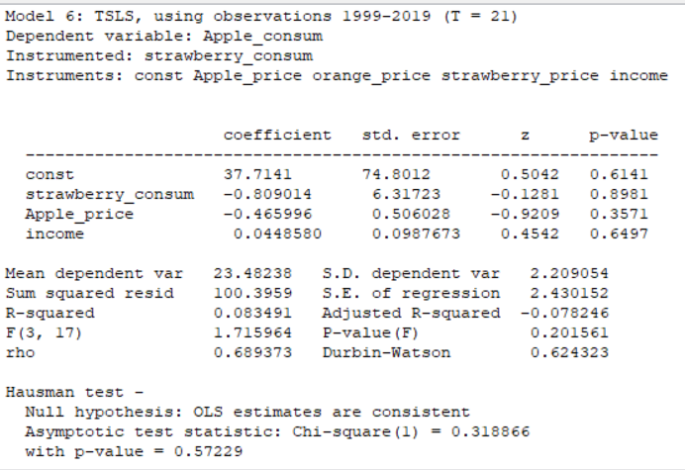

**y1t = -0.809014 y2t + 37.7141 – 0.465996 x2t + 0.0987673 x5t + u1t**

**Second Equation**

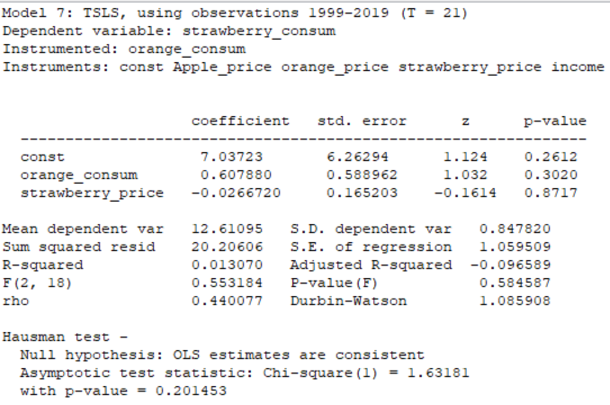

**y2t = 0.607880y3t + 7.03723 – 0.0266720x3t + u2t**

**Third Equation**

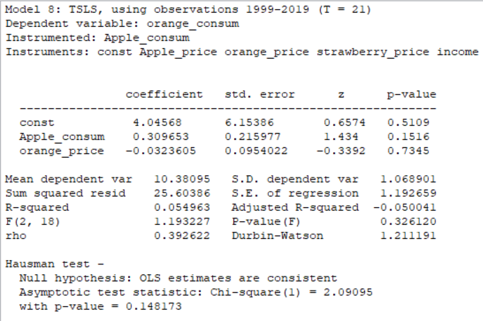

**y3t = 0.309653y1t + 4.04568 - 0.0323605x4t + u3t**

**Simultaneous Model**

y1t = -0.809014 y2t + 37.7141 – 0.465996 x2t + 0.0987673 x5t + u1t

y2t = 0.607880y3t + 7.03723 – 0.0266720x3t + u2t

y3t = 0.309653y1t + 4.04568 - 0.0323605x4t + u3t

**2.5 Economic Verification**

**y1t = -0.809014 y2t + 37.7141 – 0.465996 x2t + 0.0987673 x5t + u1t**

When income increases, apple consumption also increases. This is on par with economic theory.

When strawberry consumption decreases, apple consumption increases. This is on par with economic theory.

When apple price increases, consumption goes down. This is also on par with economic theory.

If all other variables are ignored, the consumption of apple is 37.714 kg/year per individual. This is also on par with economic theory.

**y2t = 0.607880y3t + 7.03723 – 0.0266720x3t + u2t**

When orange consumption increases, strawberry consumption also increases. This disproves the assumption that orange can be used as a substitute for strawberry.

When strawberry price increases, its consumption goes down.

If all other variables are neglected, consumption of strawberry is 7.02723 kg/year per individual.

**y3t = 0.309653y1t + 4.04568 - 0.0323605x4t + u3t**

When apple consumption increases, orange consumption also increases. This violates the assumption of orange as a substitute to apple.

When orange price increases, consumption goes down.

If all other variables are neglected, consumption of orange is 4.04568 kt/year per individual.

**Significance of Parameters**

None of the parameters of the variables are statistically significant in the three equations. Therefore, consumption of apples cannot be described significantly by the variables used.

**Coefficient of determination R2**

R2 is 0.083491 for the first equation which implies our model explains the consumption of Apples by 8.3%

R2 is 0.013070 for the first equation which implies our model explains the consumption of Strawberries by 1.3 %

R2 is 0.054963 for the first equation which implies our model explains the consumption of Oranges by 5.4%

**Durbin-Watson test**

Equation 1, DW = 0.624323

Equation 2, DW = 1.085908

Equation 3, DW = 1.211191

Since 0 < DW < 1.5 for all equations, there seems to be a positive autocorrelation in all three equations.

**2.6 Matrix B, Γ, M & Reduced Form**

y1t = -0.809014 y2t + 37.7141 – 0.465996 x2t + 0.0987673 x5t + u1t

y2t = 0.607880y3t + 7.03723 – 0.0266720x3t + u2t

y3t = 0.309653y1t + 4.04568 - 0.0323605x4t + u3t

By = Γx + U

**B** = 1 0.809014 0

0 1 -0.60788

-0.30965 0 1

**Γ** = -37.7141 0.465996 0 0 -0.09877

-7.03723 0 0.026672 0 0

-4.04568 0 0 0.032361 0

M = -B-1Γ  
V = B-1U

**M**= 26.06243821 -0.404411345 0.018726334 0.013811163 0.085714505

14.40229933 -0.076123102 -0.023147107 -0.0170716 0.016134201

12.11599218 -0.125227186 0.005798665 -0.028083832 0.026541754

**Reduced from of the Model**

**Y = MX + V**

y1t = 26.06243821x1t **-** 0.404411345 x2t + 0.018726334 x3t + 0.013811163 x4t + 0.085714505 x5t + v1t

y2t = 14.40229933 x1t - 0.076123102 x2t + 0.023147107 x3t - 0.0170716 x4t + 0.085714505 x5t + v1t

y3t = 12.11599218 x1t - 0.125227186 x2t + 0.005798665 x3t - 0.028083832 x4t + 0.026541754 x5t + v1t

**Difference Between Structural and Reduced Form**Structural equations are equations that come straightly from the underlying economic model.  
However the reduced-form equations are equations written in terms of economic variables  
which do not have a structural interpretation.

**2.7 Model Application**

**1. First Equation:**

Elasticity

**y1t = -0.809014 y2t + 37.7141 – 0.465996 x2t + 0.0987673 x5t + u1t**

**Theoretical ŷ for 2018:**

**Apple Strawberry Orange**

|  |  |  |  |  |  |  |  |
| --- | --- | --- | --- | --- | --- | --- | --- |
| 2018 | 25.40 | 13.25 | 10.19 | 29.50 | 29.46 | 30.19 | 210.56 |

**y1 y2 y3 x2 x3 x4 x5**

**y1t = - (0.809014*13.25)+ 37.7141 – (0.465996*29.50) + (0.0987673*210.56)**

**y1t =34.044**

**Elasticity for 2018:**

y2t x2t x5t

-0.312 -0.404 0.6108

**Strawberry Consumption**

If the strawberry consumption decreases by 1% then the consumption of Apple will go down by

31.2%

**Price of Apple**

If the price of Apple goes down by 1% then the consumption of Apple will go down by 40.4%.

**Household Income**

If the household income increases by 1% then the consumption of Apple will go up by 61.08%.

**2. Second Equation:**

**y2t = 0.607880y3t + 7.03723 – 0.0266720x3t + u2t**

**Theoretical ŷ for 2018:**

|  |  |  |  |  |  |  |  |
| --- | --- | --- | --- | --- | --- | --- | --- |
| 2018 | 25.40 | 13.25 | 10.19 | 29.50 | 29.46 | 30.19 | 210.56 |

**y1 y2 y3 x2 x3 x4 x5**

**y2t = 0.607880*10.19 + 7.03723 – 0.0266720*29.46**

**y2t = 6.943**

**Elasticity for 2018:**

y3t x3t

0.892 0.113

**Orange Consumption**

If the orange consumption goes up by 1% then the consumption of strawberry will go up by 89.2%.

**Price of Strawberry**

If the price of Strawberry goes up by 1% then the consumption of Strawberry will go down by 1%.

**2. Third Equation:**

**y3t = 0.309653y1t + 4.04568 - 0.0323605x4t + u3t**

**Theoretical ŷ for 2018:**

|  |  |  |  |  |  |  |  |
| --- | --- | --- | --- | --- | --- | --- | --- |
| 2018 | 25.40 | 13.25 | 10.19 | 29.50 | 29.46 | 30.19 | 210.56 |

**y1 y2 y3 x2 x3 x4 x5**

**y3t = 0.309653*25.40 + 4.04568 - 0.0323605*30.19**

**y3t = 10.933**

**Elasticity for 2018:**

y1t x4t

0.7193 -0.089

**Apple Consumption**

If the apple consumption goes up by 1% then the consumption of oranges will go up by 71.935

**Price of Orange**

If the price of Oranges goes up by 1% then the consumption of oranges will go down by 8.9%

**3. Conclusion**The single equation model is better than the multiple equation model because it is simpler and less complicated.

Strawberries and Oranges are good substitutes for Apples, though the assumption did not reflect well in our model. The fruits however can be taken as complimentary products instead of direct substitutes.

Household income per the models used did not show a significant factor in the consumption of Apple.

**4. References**

**www.czso.cz**